**URINARY SYSTEM**

Role: the urinary system function is to filter blood and create urine as a waste by product.

**Composition of urinary system**

The urinary system comprises of the following organs- two kidneys one on the right and the other on the left side of body.

* Two ureters (right & left)
* Urinary bladder
* Urethra

1. **Kidneys**

**Shape-** The kidneys are bean shaped organs approximately the size of a fist. Each kidney is surrounded by a supra renal gland.

**Location**- The kidneys are situated on the posterior wall of the abdomen.

They extend approximately between the 12th thoracic and 3rd lumbar vertebrae.

The right kidney is slightly lower than the left due to displacement by the liver.

**Blood supply to kidneys**

**Artery** – Renal artery

**Vein** – Renal vein

**Nerve supply** – Celiac plexus

**Diagram of kidney**

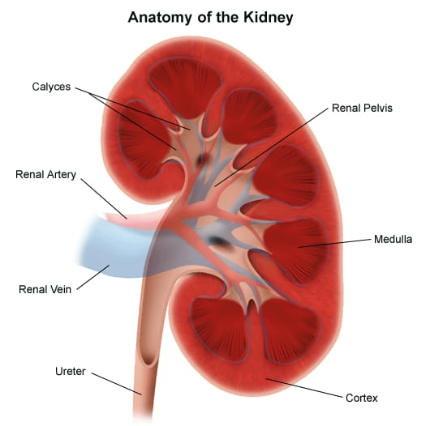

1. **Ureters**

There are two tubes that pass from the kidneys to the lower part of the urinary bladder. Their walls are made up of smooth muscles and use peristaltic contractions to move urine to the bladder. Blood supply

**Upper ureter**- Renal arteries

**Middle ureter** – Common iliac arteries

* Gonadal arteries
* Abdominal arteries

**Lower part** – Branches of internal iliac artery

1. **Urinary bladder**

This is a temporary storage.

In males it lies in front of the rectum.

In females it lies in front of uterus and vagina.

When the bladder is full of urine it is spherical in shape and extends upward into the abdominal cavity.

The walls of the bladder are made of strong smooth muscles which contract to empty the bladder. There are two sphincters which help to maintain urine in the bladder.

**The internal sphincter** – controlled sympathetic nerves.

**The external sphincter** – controlled by pudendal nerve.

1. Urethra

This is a tube which carries urine from the bladder to the external of the body.

In female the urethra ends anteriorly at the opening of the vagina (located below clitoris and above the opening of vagina).

In males the urethra is surrounded by the prostate gland and the passes through the penis.

**NB:** Female urethra is much shorter.

**Blood supply**

**Male urethra**

**Arteries**

* Injerior vesical artery
* Bulbourethral artery
* Internal pudendal artery

**Veins**

* Prostate venous plexus
* Internal iliac vein

**Female urethra**

**Arteries**

* Internal pudendal artery
* Vaginal artery

**Veins**

* Internal pudendal veins

**Diagram of urinary organs**

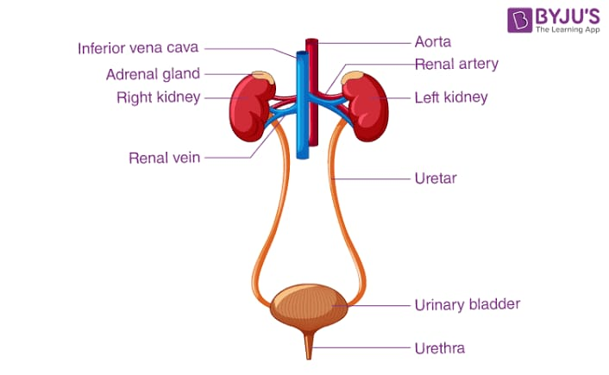

**Nephrons**

**Definition:** Nephrons are the functional units of a kidney.

They are microscopic in nature and are estimated to be approximately one million in each kidney.

**Parts of a nephron**

* Proximal convoluted tubule
* Loop of henle
* Distal convoluted tubule

The distal convoluted tubule then communicates with a collecting duct.

**Proximal convoluted tubule** – Substances like glucose, amino acids, bicarbonates, Nat, Fatty acids, Hormones, water and Minerals are reabsorbed.

**Loop of Henle** – The reabsorption of most mineral salts occurs here because some energy has tube used unlike other substances.

**Distal convoluted tubule** – Water which is needed in the body and was not reabsorbed in the proximal convoluted tubule is reabsorbed here. Substances like creatinine, urea, uric acid, toxins and water are not reabsorbed but pass from distal convoluted tubule into the collecting duct as urine. The urine is finally taken to the urinary bladder.

**Diagram of a nephron.**

